1.Create a simple cloud software application for Flight Reservation System using any Cloud Service Provider to demonstrate SaaS include the necessary fields such as one way, round trip, From, to, Departure, Departure, Travelers & Class, Fare Type, International and Domestic Flights etc.

**Step 1: Create the passenger details form in Flight reservation system**

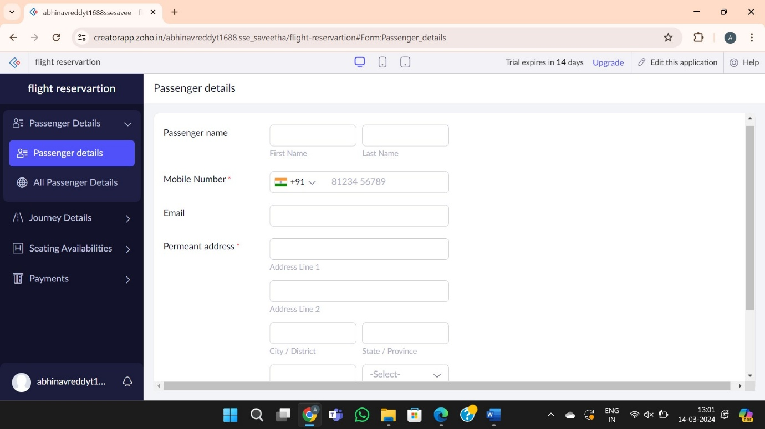

**Step 2: Create the journey details**

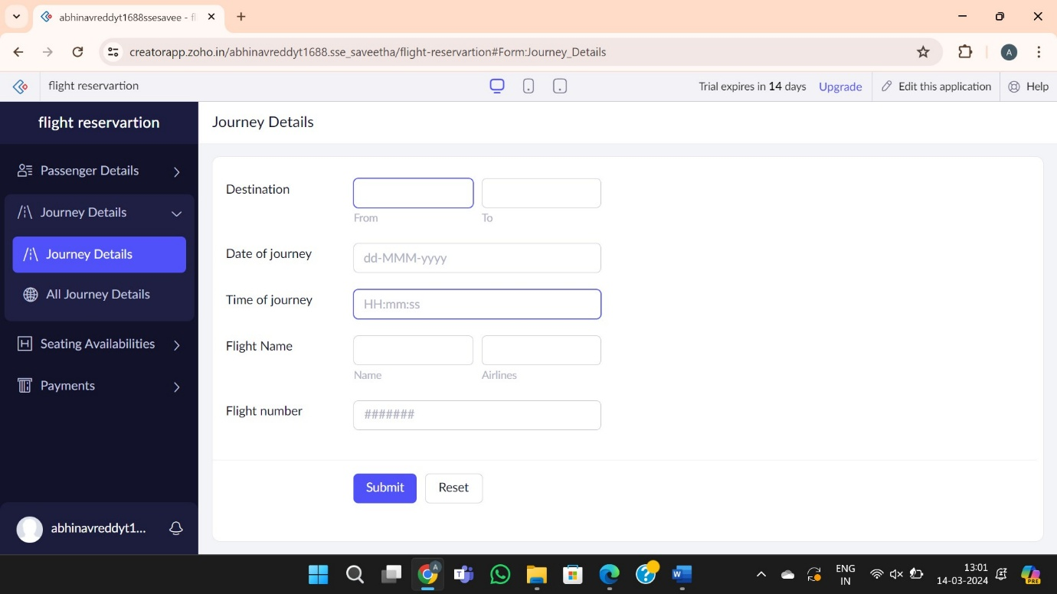

**Step 3: Seating Availability**

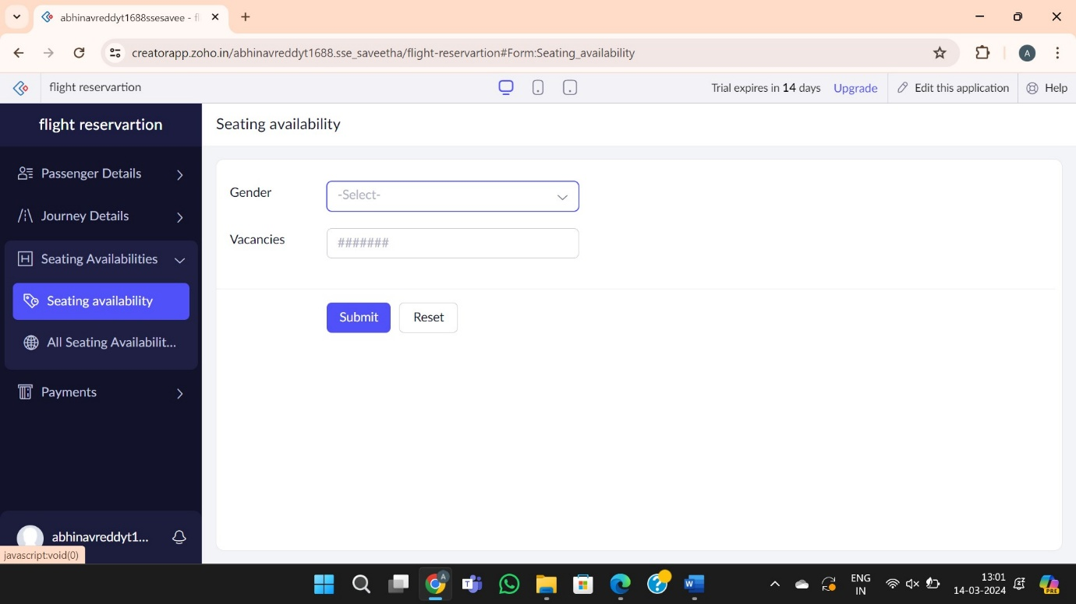

**Step 4: create the form for payment**

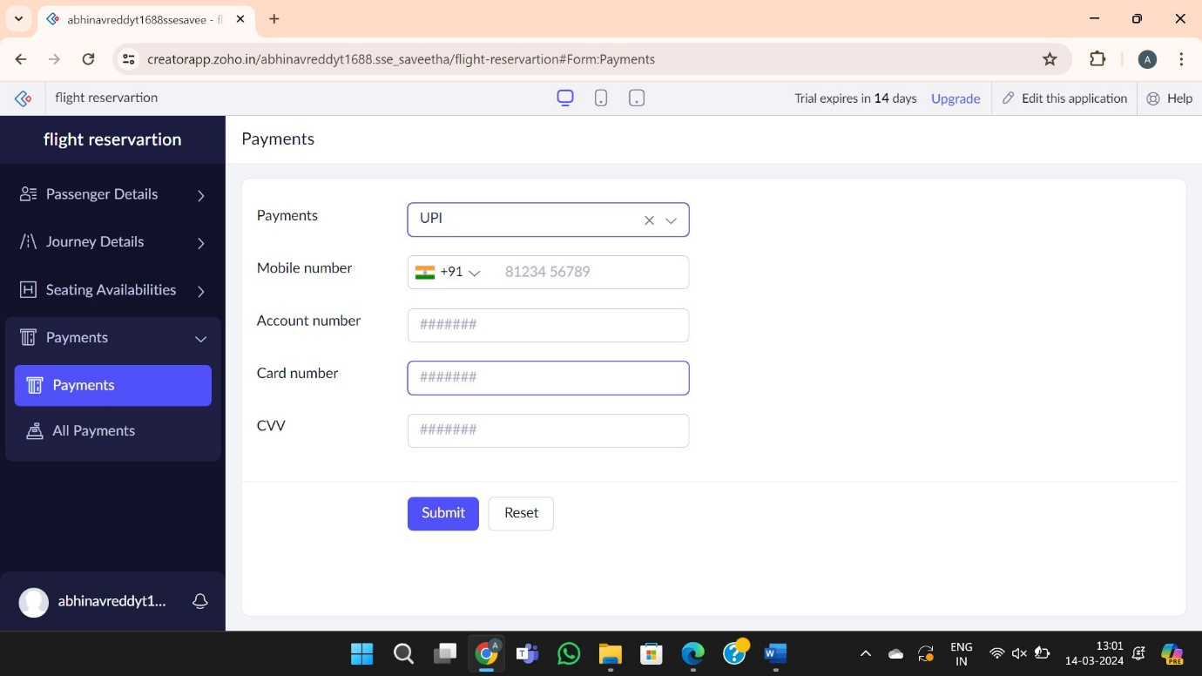

**Step 5: Report form of the flight reservation system**

